Understanding the Concepts and Definitions of Disaster
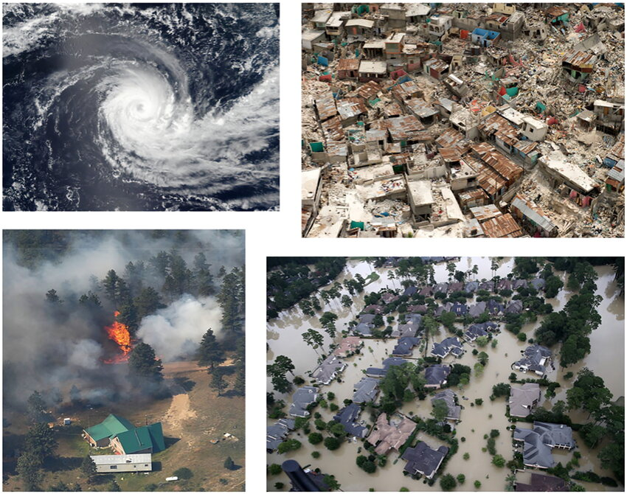
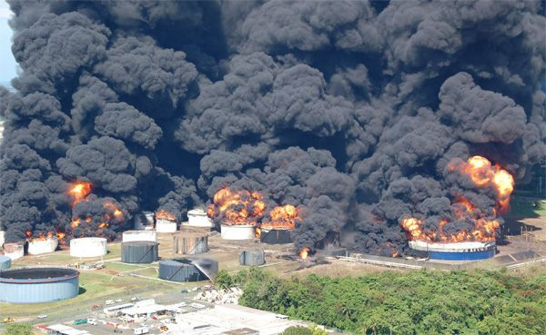
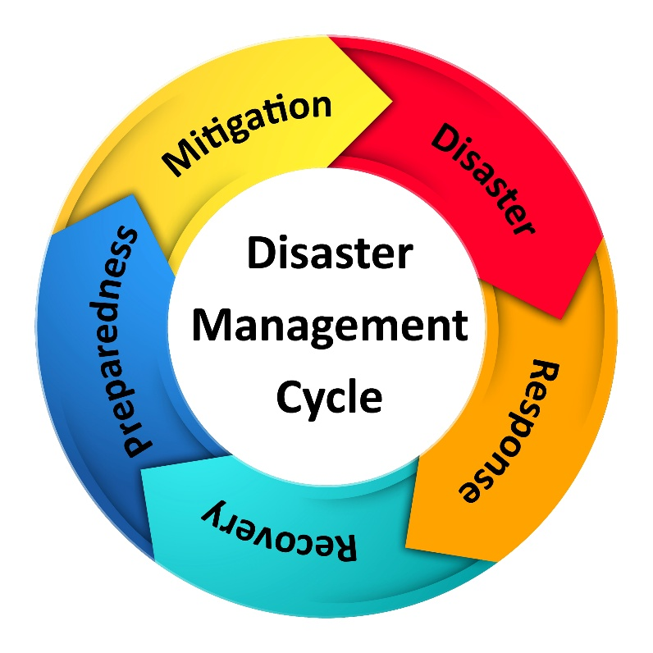

1. Introduction
A disaster is a serious disruption of the normal functioning of a community or society, causing widespread human, material, economic, or environmental losses that exceed the ability of the affected community to cope using its own resources.
Disasters can occur due to natural causes, human activities, or a combination of both, and they often result in loss of life, damage to property, and environmental degradation.

2. Definition of Disaster
Different organizations define disaster in slightly different ways:
- General Definition:
A disaster is a sudden or progressive event that causes significant damage, destruction, and human suffering.
- UN Definition:
A disaster is a serious disruption of the functioning of a community or society involving widespread losses and impacts, exceeding the affected community’s capacity to cope.

3. Key Characteristics of a Disaster
A situation is considered a disaster if it has the following features:
- Sudden or slow onset (earthquake is sudden, drought is slow)
- Large-scale impact on people and property
- Disruption of normal life
- Beyond local coping capacity
- Requires external assistance

4. Disaster vs Hazard vs Risk
Understanding these related terms is very important:
Term | Meaning
Hazard | A potentially dangerous event or phenomenon (e.g., earthquake, flood)
Risk | Probability of loss due to a hazard
Disaster | Actual occurrence causing serious damage and loss
Example:
- Earthquake (Hazard)
- Earthquake in a crowded city (Risk)
- Earthquake causing deaths and damage (Disaster)

5. Types of Disasters
A. Natural Disasters
Occur due to natural processes of the Earth.
- Earthquakes
- Floods
- Cyclones
- Droughts
- Landslides
- Tsunamis
- Volcanic eruptions
B. Man-Made (Human-Induced) Disasters
Caused due to human actions or negligence.
- Industrial accidents
- Chemical leaks
- Nuclear disasters
- Fire accidents
- Transportation accidents
- War and terrorism

6. Impact of Disasters
Disasters affect society in multiple ways:
- Human Impact: Loss of life, injuries, psychological trauma
- Economic Impact: Damage to infrastructure, industries, agriculture
- Environmental Impact: Soil erosion, water pollution, deforestation
- Social Impact: Displacement of people, disruption of education and health services

7. Disaster Management (Brief Concept)
Disaster Management refers to organized efforts to:
- Prevent disasters
- Prepare for disasters
- Respond during disasters
- Recover after disasters
This is commonly known as the Disaster Management Cycle.

8. Importance of Studying Disaster Management
- Reduces loss of life and property
- Enhances preparedness and awareness
- Promotes sustainable development
- Helps in quick response and recovery

9. Summary
- A disaster is a major disruption beyond coping capacity
- Disasters can be natural or man-made
- Understanding disaster concepts helps in effective planning and response
- Disaster Management focuses on prevention, preparedness, response, and recovery

Hazard, Vulnerability, and Risk

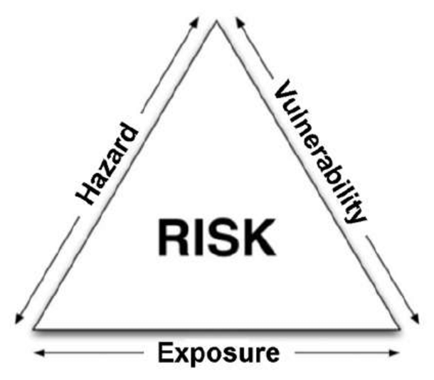

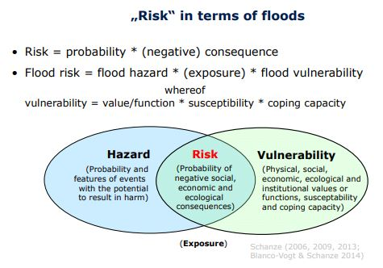
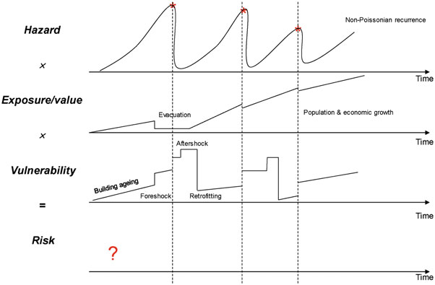

1. Introduction
In Disaster Management, Hazard, Vulnerability, and Risk are three core concepts. A disaster occurs not only because a hazard exists, but because people and systems are vulnerable to it, creating risk. Understanding the relationship among these terms helps in effective disaster prevention and mitigation.

2. Hazard
Definition
A hazard is a potentially damaging physical event, phenomenon, or human activity that may cause loss of life, injury, property damage, social and economic disruption, or environmental degradation.
Key Points
- Hazards may be natural or man-made
- A hazard does not automatically cause a disaster
- It becomes dangerous when it affects vulnerable people or systems
Types of Hazards
Natural Hazards
- Earthquake
- Flood
- Cyclone
- Drought
- Landslide
Man-Made Hazards
- Industrial accidents
- Chemical spills
- Nuclear accidents
- Fires
- Transportation accidents
Example
- An earthquake in an uninhabited desert → Hazard only
- Same earthquake in a city → Potential disaster

3. Vulnerability
Definition
Vulnerability refers to the degree to which individuals, communities, or systems are likely to be affected by a hazard due to physical, social, economic, or environmental factors.
Characteristics of Vulnerability
- Increases the impact of hazards
- Varies from place to place and group to group
- Can be reduced through planning and preparedness
Types of Vulnerability
- Physical Vulnerability
  - Weak buildings
  - Poor infrastructure
- Social Vulnerability
  - Poverty
  - Illiteracy
  - Age (children, elderly)
- Economic Vulnerability
  - Low income
  - Dependence on agriculture
- Environmental Vulnerability
  - Deforestation
  - Living near rivers or coastal areas
Example
- Poorly constructed houses are more vulnerable to earthquakes.

4. Risk
Definition
Risk is the probability or likelihood of harmful consequences resulting from the interaction between a hazard and vulnerability.
Risk Formula
Risk = Hazard × Vulnerability
This means:
- If either hazard or vulnerability is zero, risk is minimal
- High hazard + high vulnerability = high risk
Key Features of Risk
- Risk can be assessed and managed
- Risk can be reduced by reducing vulnerability
- Risk is not fixed; it changes with time and conditions
Example
- Flood hazard + settlements on riverbanks = high flood risk

5. Relationship between Hazard, Vulnerability, and Risk
Term | Meaning | Can it be Reduced?
Hazard | Potentially dangerous event | Usually No
Vulnerability | Susceptibility to harm | Yes
Risk | Chance of loss or damage | Yes
Disaster occurs when a hazard affects a vulnerable population, creating high risk.

6. Real-Life Example (Flood Scenario)
- Hazard: Heavy rainfall
- Vulnerability: Poor drainage, houses near river
- Risk: Flooding causing damage and loss of life

7. Importance in Disaster Management
- Helps identify high-risk areas
- Assists in planning and mitigation
- Reduces loss of life and property
- Improves disaster preparedness strategies

8. Summary
- Hazard is a potential threat
- Vulnerability is the level of weakness
- Risk is the chance of loss due to hazard and vulnerability
- Reducing vulnerability is the key to reducing risk

Capacity – Disaster, Development

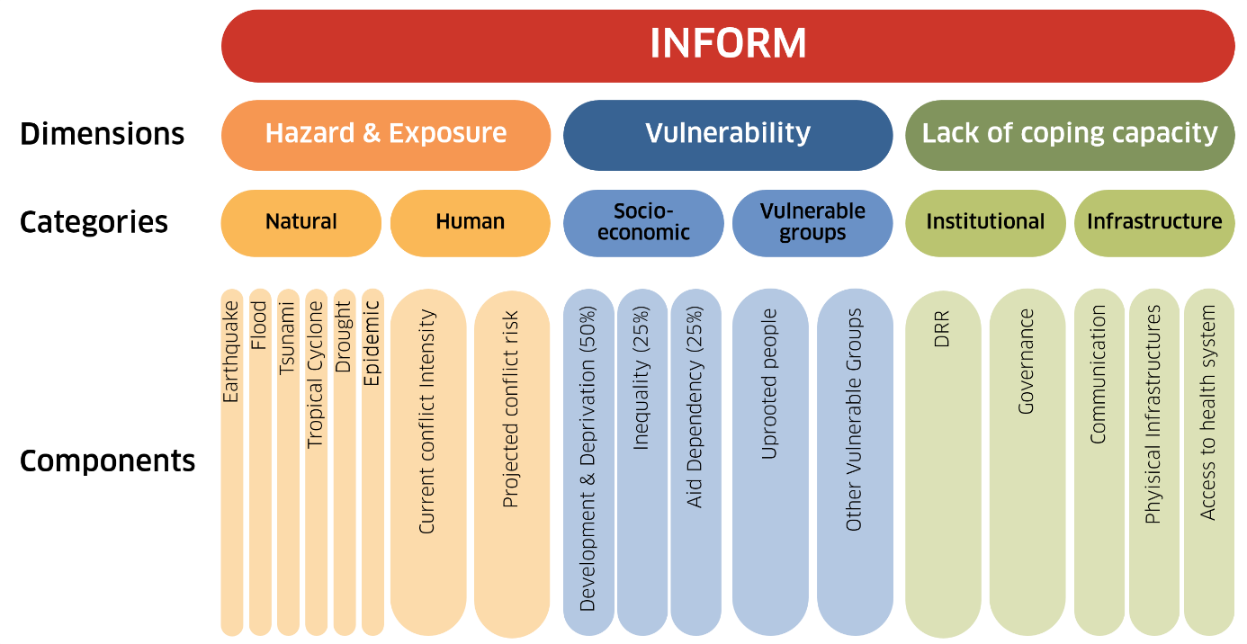

1. Introduction
In Disaster Management, Capacity plays a crucial role in reducing disaster impacts. While hazards and vulnerability increase disaster risk, capacity helps individuals, communities, and institutions prepare for, respond to, and recover from disasters. Capacity is closely linked with development, as better development enhances disaster resilience.

2. Capacity
Definition
Capacity refers to the strengths, resources, skills, knowledge, and abilities available within a community, organization, or system that can be used to anticipate, cope with, resist, and recover from the impacts of disasters.
Key Elements of Capacity
- Knowledge and awareness
- Skills and training
- Physical resources
- Strong institutions and governance
- Community participation
Types of Capacity
- Physical Capacity
  - Strong buildings
  - Roads, hospitals, shelters
- Social Capacity
  - Community cooperation
  - Volunteer networks
- Economic Capacity
  - Financial resources
  - Insurance and savings
- Institutional Capacity
  - Disaster response agencies
  - Early warning systems
- Technological Capacity
  - Communication systems
  - Forecasting and monitoring tools
Example
- A community trained in first aid and evacuation has high capacity to deal with floods.

3. Relationship between Capacity, Hazard, Vulnerability, and Risk
Disaster Risk = (Hazard × Vulnerability) ÷ Capacity
- Higher capacity → Lower disaster risk
- Lower capacity → Higher disaster risk
Capacity helps reduce vulnerability and improves response efficiency.

4. Disaster and Development
Meaning
Disaster and development are interrelated processes. Poor development increases disaster risk, while good development reduces vulnerability and strengthens capacity.
How Poor Development Increases Disasters
- Unplanned urbanization
- Poor housing conditions
- Environmental degradation
- Lack of basic services
How Good Development Reduces Disaster Impact
- Strong infrastructure
- Education and awareness
- Poverty reduction
- Sustainable environmental practices
Disaster–Development Cycle
- Disasters damage development gains
- Poor development increases disaster losses
- Sustainable development breaks this cycle

Disaster Management
Definition
Disaster Management is the organized and systematic process of using resources, capacities, and strategies to reduce disaster impacts and ensure effective response and recovery.
Objectives of Disaster Management
- Minimize loss of life and property
- Reduce vulnerability
- Enhance community capacity
- Ensure quick response and recovery

6. Phases of Disaster Management
1. Prevention & Mitigation
- Risk assessment
- Building codes
- Environmental protection
2. Preparedness
- Training and drills
- Early warning systems
- Emergency planning
3. Response
- Search and rescue
- Medical aid
- Relief distribution
4. Recovery
- Rehabilitation
- Reconstruction
- Livelihood restoration
Capacity plays a role in every phase of disaster management.

7. Role of Capacity in Disaster Management
- Improves preparedness
- Ensures efficient response
- Speeds up recovery
- Promotes self-reliance
- Reduces dependence on external aid

8. Importance of Capacity Building
- Reduces disaster losses
- Strengthens resilience
- Encourages community participation
- Supports sustainable development
- Enhances national disaster preparedness

9. Summary
- Capacity is the ability to manage disasters effectively
- Higher capacity reduces disaster risk
- Disaster and development are closely linked
- Disaster Management uses capacity to prevent, prepare, respond, and recover
- Capacity building is essential for sustainable and resilient societies

